ver. 2017-12-13_jb

Lesson Learned: “Scoping” ideas for discussion & development

Identify experience you feel have a "lessons learned" component you wish to share with other Landscape Conservation Coordinators / Practitioners?
- Area of: working with your Steering Committee (decision-making body) - a) what worked well and why? b) not so well and what needs to change?
- Area of: working with your technical / consultative fora (whether that be assembled or standing membership) - a) what worked well and why? and b) not so well and what needs to change?
- Area of: contracts and grants in terms of TECHNICAL oversight (i.e., not fiscal reporting etc.) - a) what worked well and why? and b) not so well and what needs to change?
- Area of: coordination and supervision/direction for host (funding) agency - a) what worked well and why? and b) not so well and what needs to change?
- Area of: reporting contributions / impacts to advancing the science (remember only LL, not 'success stories' per se) - a) identifying science needs / scope of work, b) solicitation and selection, c) distribution of research products, d) (if appropriate) training
- Area of: reporting contributions / impact to facilitation of, or creation of networks - a) awareness of "who's working where", b) information sharing, c) resource / tool sharing, d) convening / periodic meeting, e) professional meeting / continuing education and professional development…
- ….

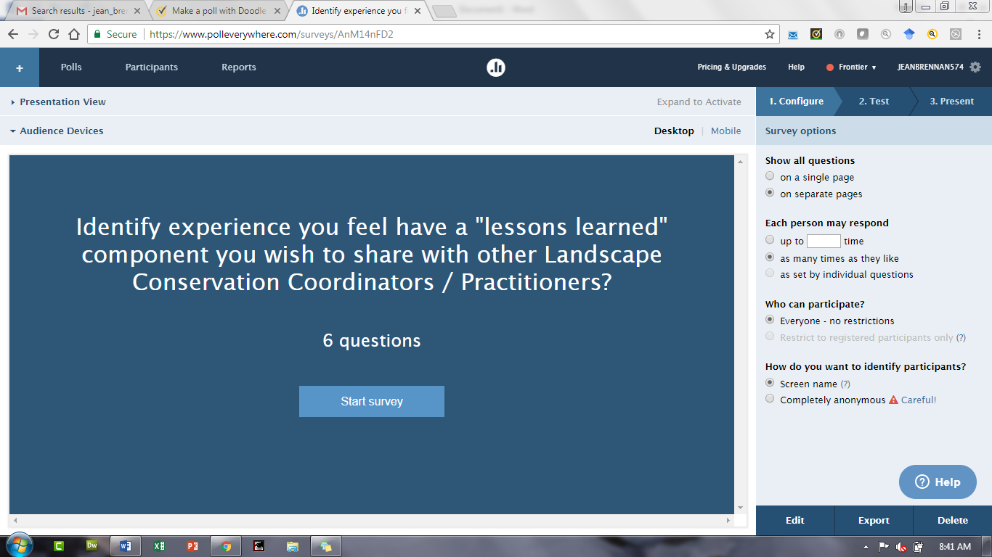

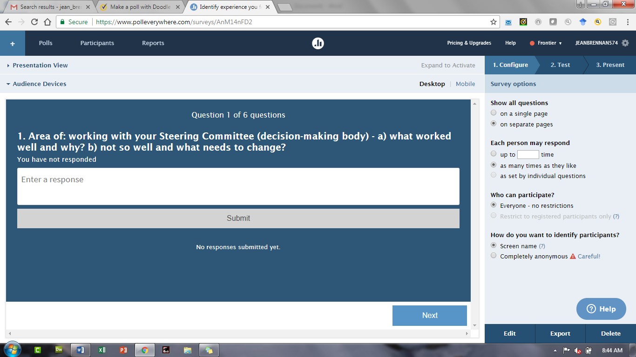

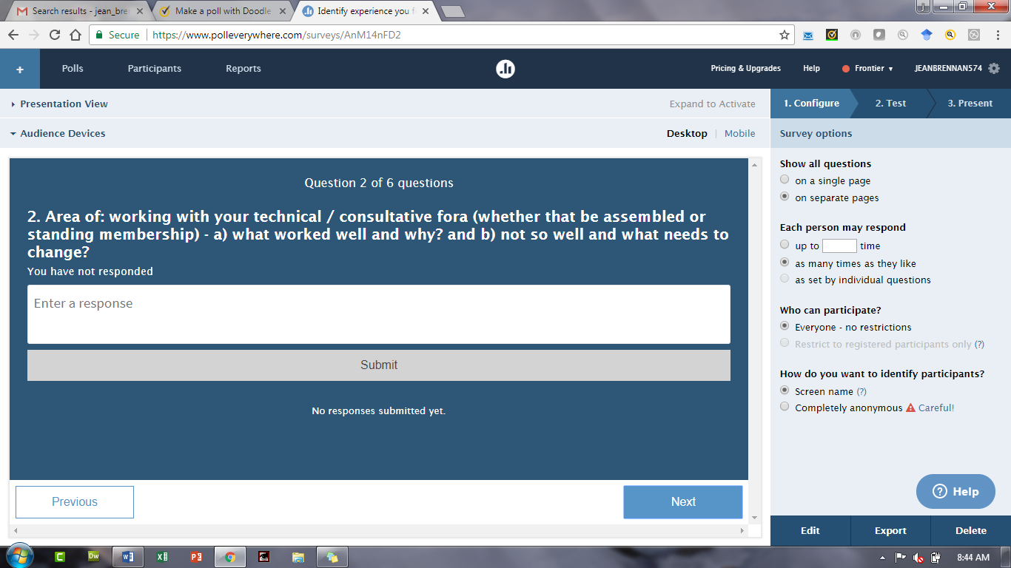

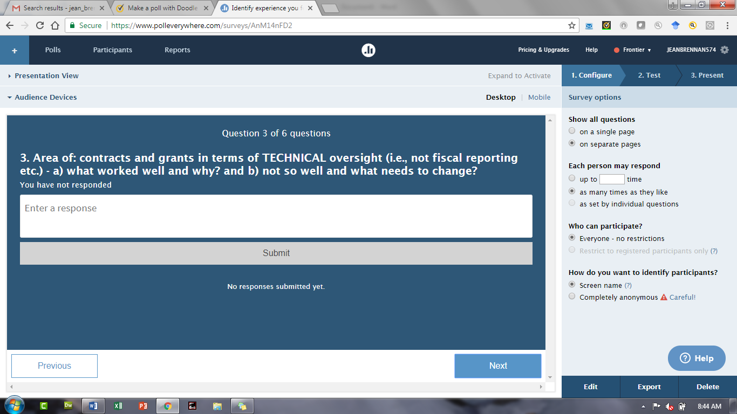

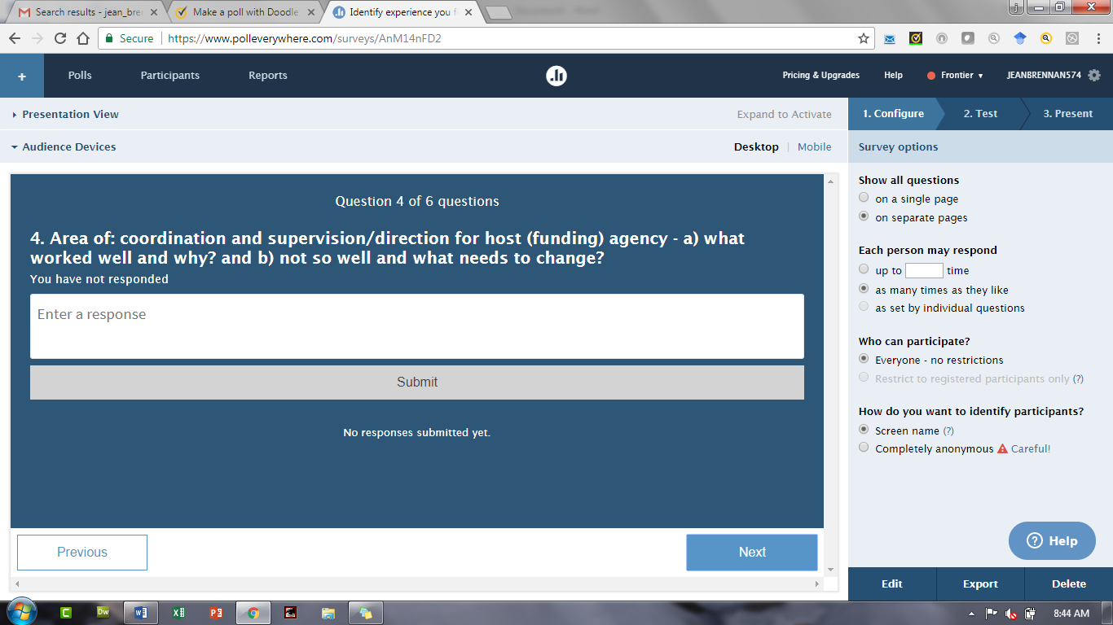

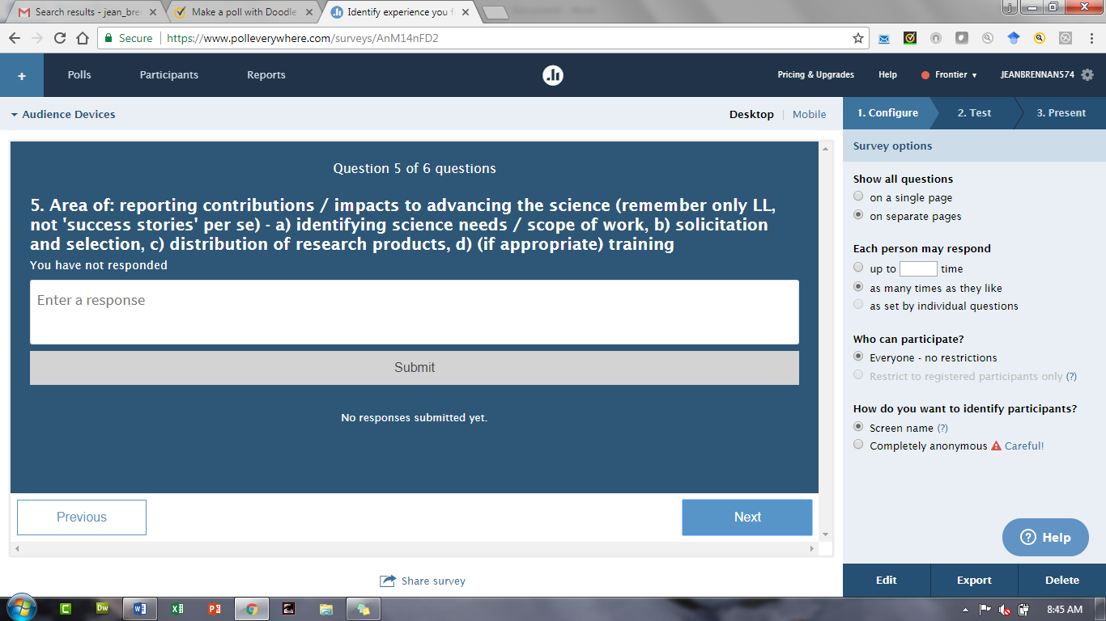

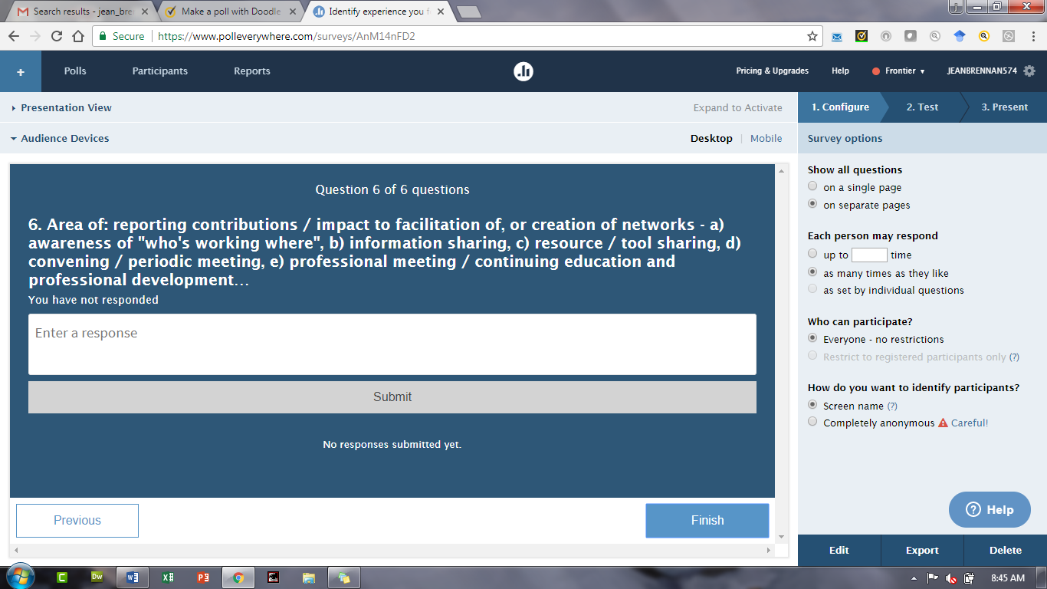

https://PollEv.com/surveys/AnM14nFD2/web

[from: https://www.polleverywhere.com/ ]

